The system is developed using asp.net. I put two projects in the repository. The main system which is a web service is in a solution named “MiniaturePricerServer”. It has 2 classes:

A web service: PricingService.asmx

And a class library for Interpolation that uses the Lagrange algorithm for interpolation.

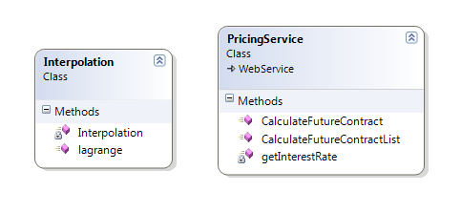

The web service has two web methods. Both methods get 2 input parameters.

The first method gets a single price parameter and returns the future price for it :

public decimal CalculateFutureContract(decimal currentPrice, short dayInYear)

While the second method gets a list of current prices and return a list of future prices:

public List<decimal> CalculateFutureContractList(List<decimal> currentPriceList, short dayInYear)

In order to test this service, I wrote a simple web application that has a reference to this web service: MiniaturePrice1

This application has a simple*. aspx* web page that gets the current price and the number of days in future,

and uses the web service to show the future contract:

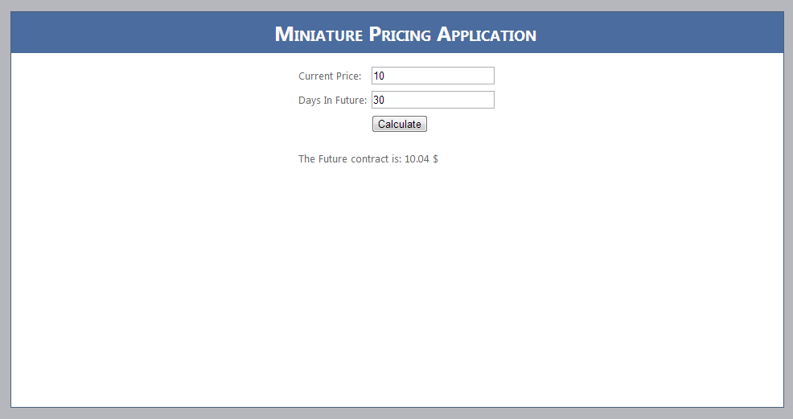

protected void btnCalculate_Click(object sender, EventArgs e)

{

PricingService.PricingService service = new PricingService.PricingService();

lblFutureContract.Text ="The Future contract is: "+

service.CalculateFutureContract(decimal.Parse(txtCurrentPrice.Text), short.Parse(txtDays.Text)).ToString() + " $";

}